Author: Luowei Chen

Contents
Abstract 1
Introduction 1
Materials and Methods 5
Results 6
Discussion 15
Literature Cited 17

Abstract

This report aims to provide the procedure of analyzing Chicago Insurance redlining data with LDA algorithm. The first part will be discussing the methods checking the equal variance and normality assumption. The second part will be targeting at the implementation of LDA algorithm. Our results show that with the variables we choose, the LDA algorithm can generate reasonable classification outcomes.

Introduction
LDA is a traditional classification model which is closely related to analysis of variance. With the vigorous requirements of variance consistency and distribution normality, it is essential to verify the assumption and select variables accordingly. After checking the assumption and selecting necessary features, we will fit the data with both LDA and QDA model. At last prat, the performance checking for our classification model comparison between LDA and QDA will be provided.

Data being used is from a 1970's study on the relationship between insurance redlining in Chicago and racial composition, fire and theft rates, age of housing and income in 47 zip codes. This report will present the whole process checking whether this dataset is eligible to classify the “side” (south or north) according to other features.

- Quadratic Discriminant Analysis
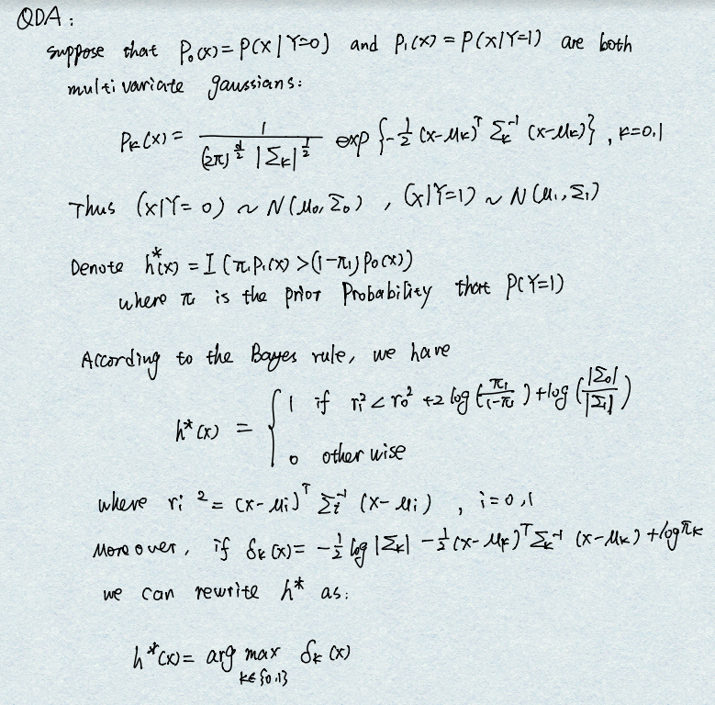
- Linear Discriminant Analysis for Two Classes
(LDA) is most commonly used as dimensionality reduction technique in the pre-processing step for pattern-classification and machine learning applications. The goal is to project a dataset onto a lower-dimensional space with good class-separability in order avoid overfitting (“curse of dimensionality”) and also reduce computational costs.

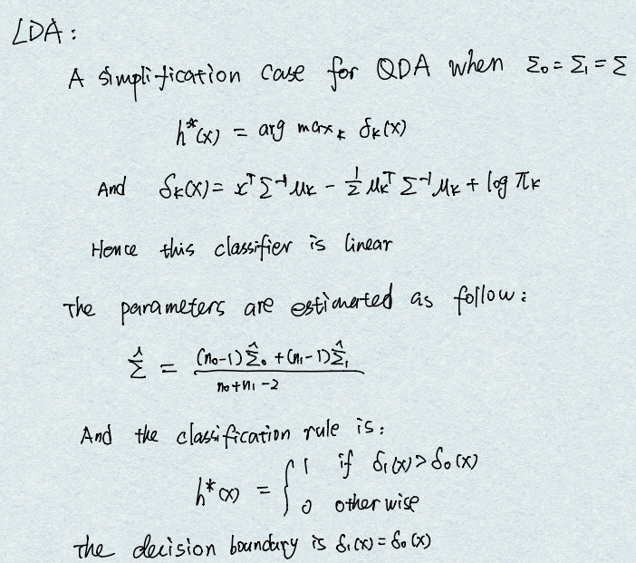
- LDA Assumptions
LDA is quite sensitive to outliers and the size of the smallest group must be larger than the number of predictor variables.
- Multivariate normality: Independent variables are normal for each level of the grouping variable.
- Homogeneity of variance/covariance (homoscedasticity): Variances among group variables are the same across levels of predictors. Usually, that linear discriminant analysis be used when covariances are equal, and that quadratic discriminant analysis may be used when covariances are not equal.
- Multicollinearity: Predictive power can decrease with an increased correlation between predictor variables.
- Independence: Participants are assumed to be randomly sampled, and a participant's score on one variable is assumed to be independent of scores on that variable for all other participants.

LDA actually is relatively robust to slight violations of these assumptions

- Fisher’s Linear Discriminant
- Compute the d-dimensional mean vectors for the different classes from the dataset.
- Compute the scatter matrices (in-between-class and within-class scatter matrix).
- Compute the eigenvectors (e1,e2,...,ed) and corresponding eigenvalues (λ1,λ2,...,λd) for the scatter matrices.
- Sort the eigenvectors by decreasing eigenvalues and choose k eigenvectors with the largest eigenvalues to form a dxk dimensional matrix W (where every column represents an eigenvector).
- Use this dxk eigenvector matrix to transform the samples onto the new subspace. This can be summarized by the matrix multiplication :Y=X×W(where X is a n×d-dimensional matrix representing the n samples, and y are the transformed nxk -dimensional samples in the new subspace).

- ROC Curve
ROC stands for Receiver Operating Characteristic. Its origin is from sonar back in the 1940s; ROCs were used to measure how well a sonar signal (e.g., from an enemy submarine) could be detected from noise (a school of fish).
  - Confusion Matrix: the matrix can calculate TP (true positives) and FP (false positives)
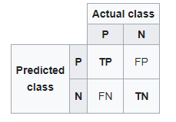
  - ROC curve
In the current usage, ROC curves are a nice way to see how any predictive model can distinguish between the true positives and negatives.
Steps for plotting ROC：
- Acquire LDA model results
- Generate actual and predicted values for test sets
- Calculated the FP rate and TP rate for all thresholds of the classification.
- 4) Finally we plot the FP rate versus TP rate

  - AUC value
The area under the curve is AUC. AUC should value from 0 to 1, the closer to 1 means the better classification performance

Materials and Methods
- Dataset Overview
A dataframe with 7 columns and 47 rows. With following 7 variables:
race: racial composition in percent minority
fire: fires per 100 housing units
theft : theft per 1000 population
age : percent of housing units built before 1939
involact: new FAIR plan policies and renewals per 100 housing units
income : median family income in thousands of dollars
side : dependence variable we want to predict. North or South side of Chicago

- Data Cleaning and Assumption Checking
- Remove Outliers. Consider removing outliers from your data. These can skew the basic statistics used to separate classes in LDA such the mean and the standard deviation.
- Gaussian Distribution. The standard implementation of the model assumes a Gaussian distribution of the input variables. Consider reviewing the univariate distributions of each attribute and using transforms to make them more Gaussian-looking (e.g. log and root for exponential distributions and Box-Cox for skewed distributions).
- Same Variance. LDA assumes that each input variable has the same variance. It is almost always a good idea to standardize your data before using LDA so that it has a mean of 0 and a standard deviation of 1.

- LDA Classification Model Construction
  - Separate dataset into training data set and testing data set
  - Using MASS::lda command in R to do LDA
  - Calculate basic classification measurement statistics
  - Plot ROC curve
  - Compare results with QDA

Results
- Variance and Distribution Check
- Boxplot
Boxplot can show the basic variable ranges in a friendly visualization. Following are all the six features’ boxplot

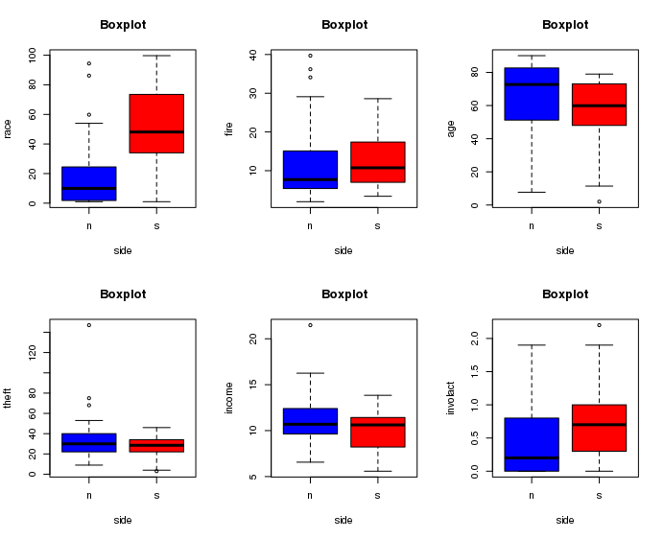
(1)
- Covariance and Variance
The error ellipse represents an iso-contour of the Gaussian distribution, and allows you to visualize a 2D confidence interval.
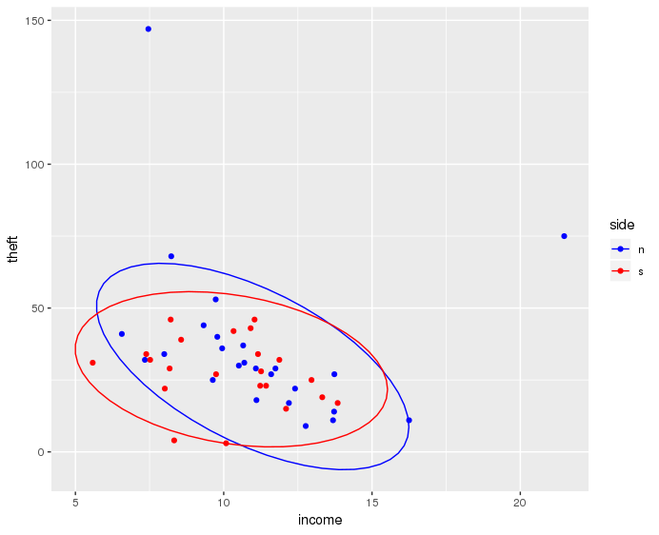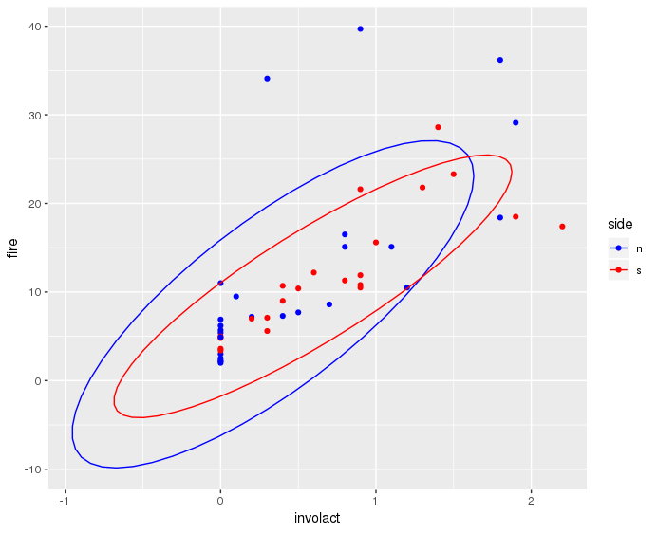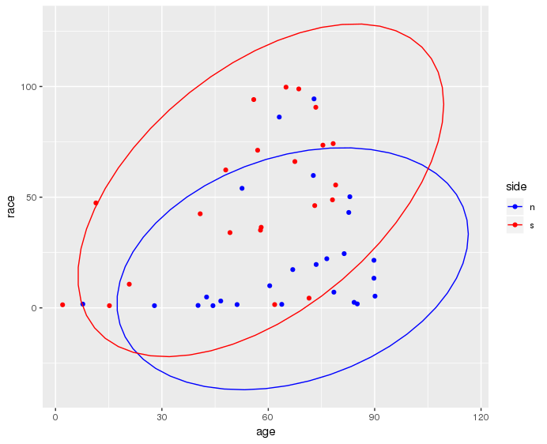
(2)

- Distribution and Normality
A Q-Q plot is a scatterplot created by plotting two sets of quantiles against one another. If both sets of quantiles came from the same distribution, we should see the points forming a line that’s roughly straight. Here’s an example of a Normal Q-Q plot when both sets of quantiles truly come from Normal distributions.

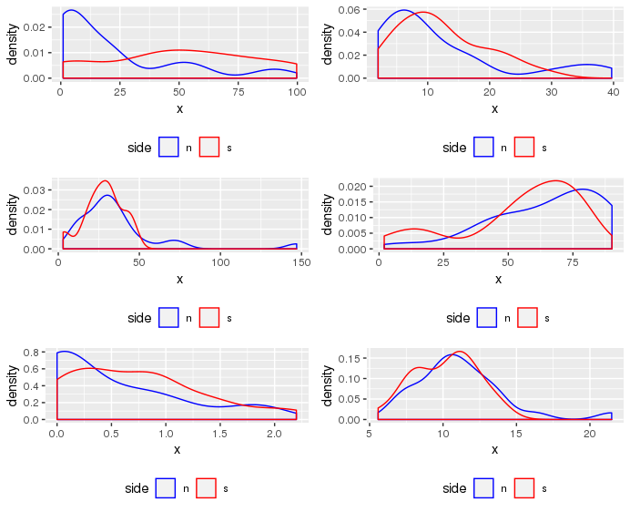
(3-1)
North group qq plot
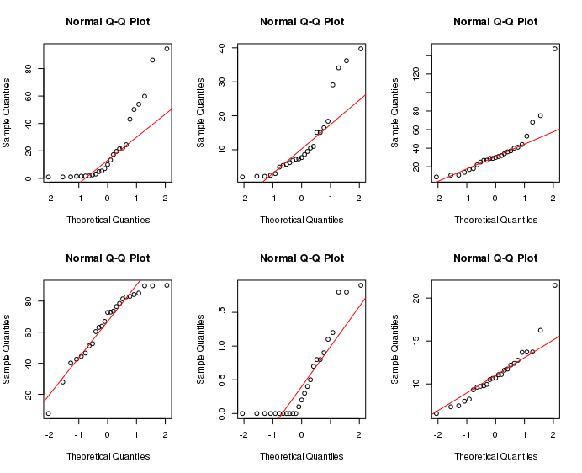
(3-2)
South group qq plot
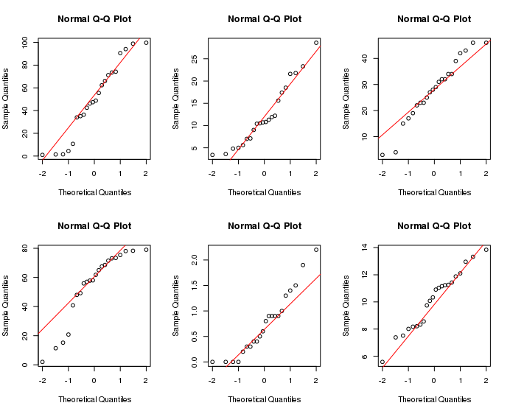
(3-3)

- LDA Model Results
    - Fitted Model
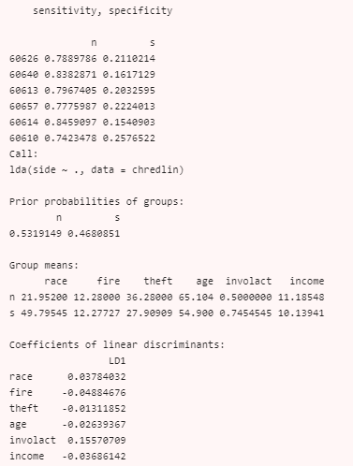

    - Predicted Values
We Presented the predicted values by using confusion matrix. By calculating the confusion matrix, we can get that this model has a classification accuracy of:
Accuracy = (21+17)/47 = 0.809
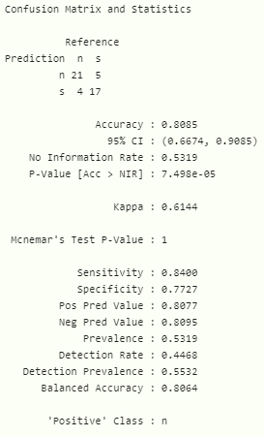

    - ROC Curve
ROC curve should be our main measurement for classification model performance. Generally, if the AUC of the corresponding ROC is bigger than 0.8, the model can be regarded as efficient.
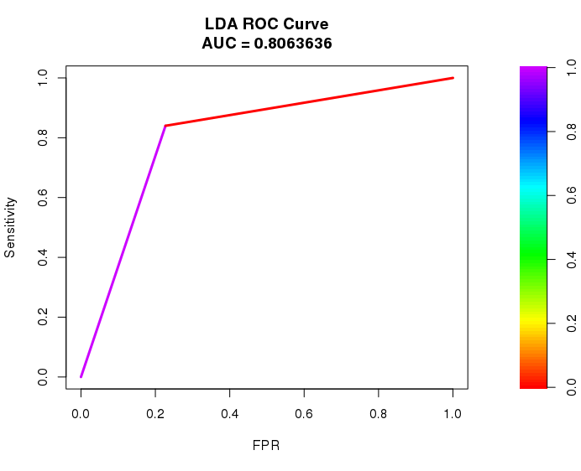
- QDA Model Results
    - Fitted Model
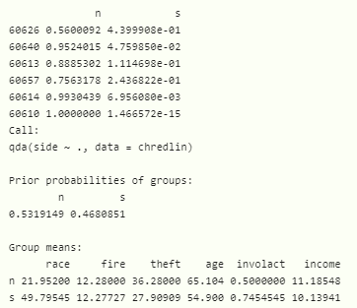
- Predicted Values
We Presented the predicted values by using confusion matrix. By calculating the confusion matrix, we can get that this model has a classification accuracy of:
Accuracy = (22+20)/47 = 0.894

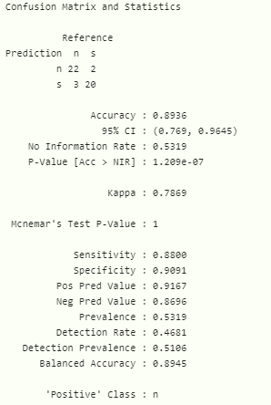
- ROC Curve
ROC curve should be our main measurement for classification model performance. Generally, if the AUC of the corresponding ROC is bigger than 0.8, the model can be regarded as efficient
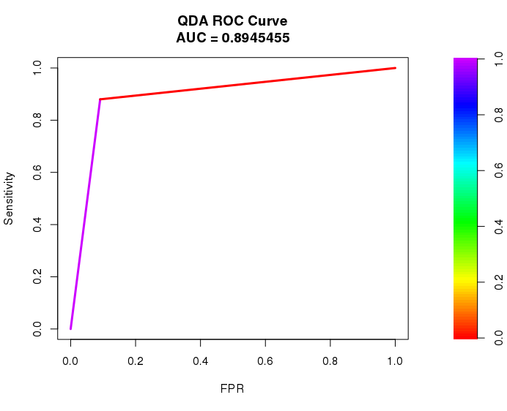

Discussion
- Assumption Check
Plot (1) shows the boxplot for six features in both classes (n class and s south). Except for the first race feature, other 5 features seem to have similar variable range. Furthermore, we will check the covariance and variance assumption.
Plot (2) provided three covariance ellipsoid sample. The more similar two shapes are, the closer their covariance should be. We also used Levene Test to test homogeneity of variance and here is the form of our equal variance conclusion:

All the features pass the Levene test therefore can be regarded as having equal variance which is one of the key assumption of applying LDA Model. Next step we will check the distribution and normality of each feature.

Then we separated two groups and plotted the smoothed density function of six variables. The density function tells us that the majority of these variables have heavy tails (left tail or right tail), meaning that the distribution of each feature is not normally distributed.
Same conclusion can be drawn from the qq-plot. For example, in north group, first and third features are having obvious fat tail the upper side. In south group, the third and fourth feature are presenting apparent fat tail as well but on the downside.

- LDA Model
After variance and normality check, we think this data set can be used for LDA model fit. Since LDA is a linear model and we acquired each features corresponding coefficient.
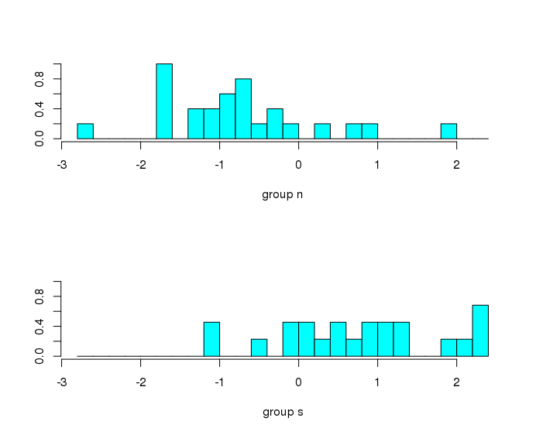
The above plot shows a relative obvious trend to linearly separate two groups. In results, LDA reaches accuracy and AUC value both higher than 0.8 which also indicates that LDA can reasonable separate this data set with given six features.

- QDA Model
According to previous procedure, we are ignoring some equal variance and normality assumption, by switching to QDA, the algorithm that does not require strict same covariance matrix, it is possible to get more accuracy for classifiers.

- Comparison
With the confusion matrix we provided, QDA has basically same ability to classify n group as LDA model; meanwhile, QDA presents a better capability to predict s group correctly compared with LDA. The QDA classification accuracy is also higher than LDA.
Moreover, QDA has an AUC close enough to 0.9, which is an extremely good results for classification. In comparison, LDA can only achieve an AUC around 0.8.

Literature Cited

